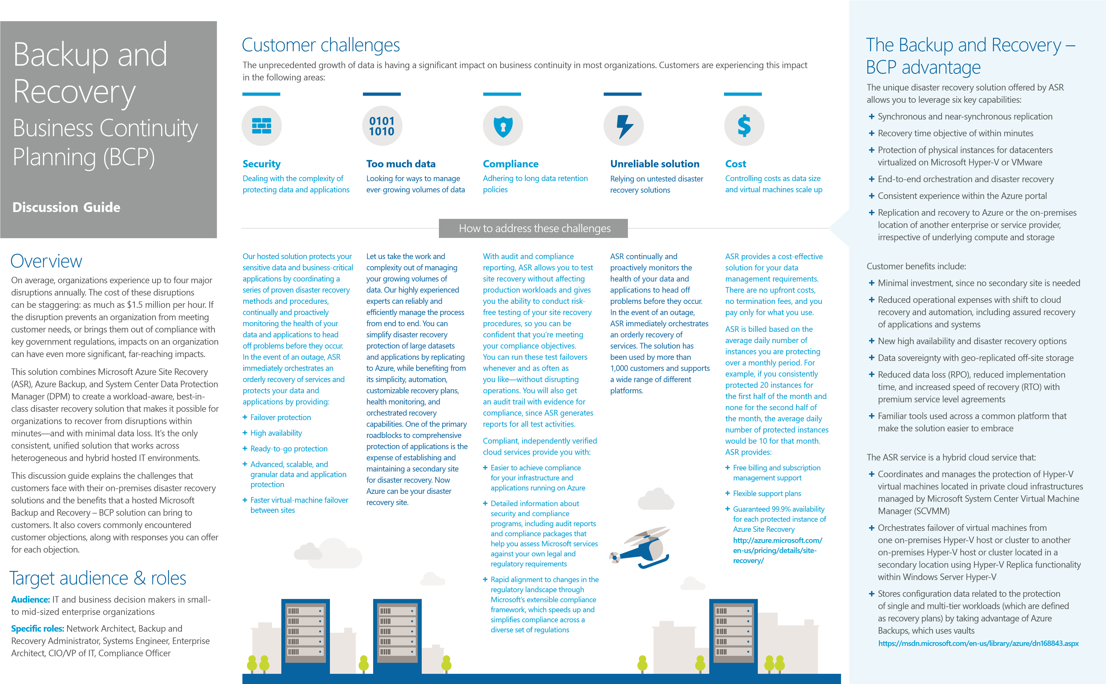

Objections
We have an in-house disaster recovery solution that we know works. We’re interested in a cloud solution, but how can we have confidence in ASR, since we don’t know it as well as our on-premises disaster recovery solution?
Your answer:
ASR protects your sensitive data and business-critical applications by coordinating a series of proven disaster recovery methods and procedures. Our tested Azure-based solution continually and proactively monitors the health of your data and applications to head off problems before they occur. In the event of an outage, our solution immediately orchestrates an orderly recovery of services. Our rigorously tested solution is used by many customers, ranging from small businesses to enterprise-level organizations.
We have an in-house disaster recovery solution with our own server infrastructure, and we’re concerned that a hosted disaster recovery solution will be too costly.
Your answer:
Our hosted service provides a cost-effective, pay-as-you-go solution for your disaster recovery needs. You only pay for resources you actually consume, instead of maintaining an expensive, permanent in-house solution.
We’re a fast-growing company. We’re concerned that as our business grows, a hosted disaster recovery solution won’t be able to scale with our business, and that our large datasets will be at risk.
Your answer:
Backup and Recovery – BCP can help you protect important services by coordinating the automated replication and recovery of protected instances at a secondary location. There are three primary deployment options.
Virtual machines running in an environment using Hyper-V can be replicated between two datacenters. ASR monitors the health of applications running on the primary site, stores the recovery plan, and executes it when needed. In the event of a site outage at the primary datacenter, virtual machines are recovered in an orchestrated fashion to help restore service quickly. This process can also be used for testing recovery or temporarily transferring services.
You can replicate virtual machines from your primary site directly
“as-is.” Information and views expressed in this document, including URL and to Azure, instead of your own secondary site. In the event of an other Internet Web site references, may change without notice. You bear the risk
of using it. This document does not provide you with any legal rights to any outage at the primary site, the service orchestrates the recovery of
intellectual property in any Microsoft product. You may copy and use this document for your internal, reference purposes. You may modify this document virtual machines in Azure. for your internal, reference purposes.
ASR subscriptions include recently acquired InMage Scout technology, which enables the protection of VMware and physical environments.
InMage Scout is currently included as separate software.
If you purchase ASR through the Microsoft Enterprise Agreement via a plan SKU, you will receive 100 GB of geographically redundant storage (GRS), 1 million storage transactions, and 100 GB of egress per instance. Otherwise, separate charges for storage, storage transactions, and data transfers apply.
Our hosted solution leverages the advanced, scalable, and granular data and application protection of Azure. Our solution's built-in, application-specific functionality helps protect Microsoft Exchange Server, SQL Server, SharePoint, Hyper-V, and the data that powers them—all with a
single agent.
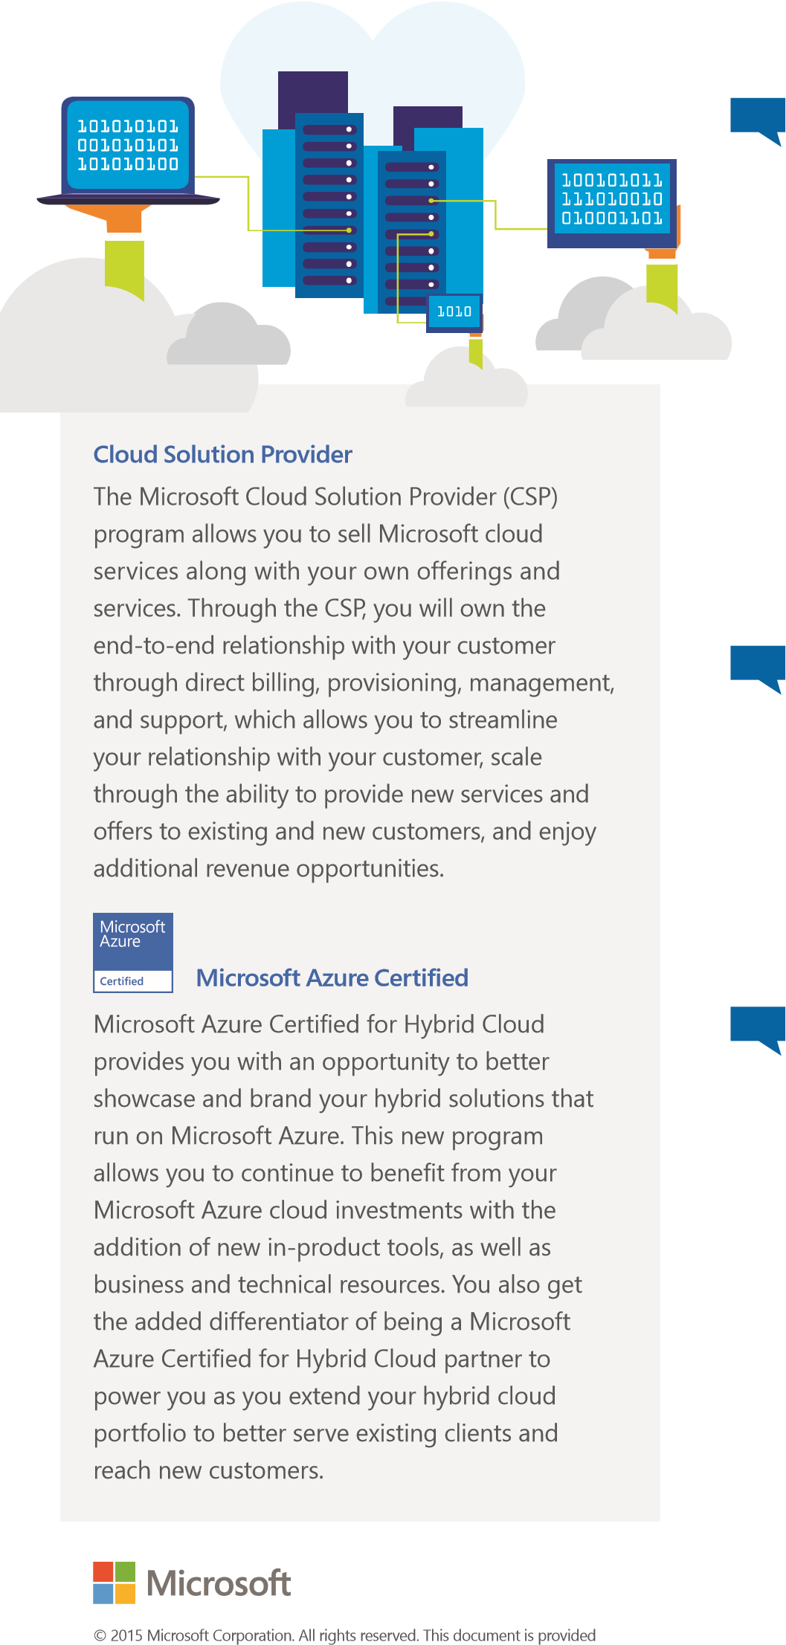
Data in your storage account is replicated to ensure durability that is also highly available, meeting the Azure Storage SLA even in the face of transient hardware failures. Azure Storage is deployed in 15 regions around the world and also includes support for replicating data among regions. Your options for replicating the data in your storage account include the following:
Locally redundant storage (LRS) maintains three copies of your data. LRS is replicated three times within a single facility in a single region. LRS protects your data from normal hardware failures, but not from the failure of a single facility. LRS is offered at a discount. For maximum durability, we recommend that you use zoneredundant storage.
Zone-redundant storage (ZRS) maintains three copies of your data. ZRS is replicated three times across two to three facilities, either within a single region or across two regions. It provides higher durability than LRS and ensures that your data is durable within a single region.

Resources
Cloud Solution Provider
Microsoft Azure Certified for Hybrid Cloud
Azure Site Recovery
Microsoft Azure Certified for Hybrid Cloud portal
Server and cloud platform—business community
Your customers will likely face one of two scenarios:
Fractured solutions (most likely). Your customers are using multiple products for backup, replication, and disaster recovery, perhaps even different products for differing infrastructures.
Unified solution (less likely). Your customers have an integrated solution for physical and virtual environments, but that solution doesn’t support a cloud environment or offer disaster recovery as a service (DRaaS). If they have multiple products, we advise that you pitch our heterogeneity and ability to offer simplification with one solution, support their future cloud needs, and provide future validation to the “one solution” offering. If they have an integrated product and lack cloud capabilities, highlight our cloud support, which can help power their end-to-end vision with less complexity.
The key selling motion around heterogeneity is solving a “three tense” problem—past, present, and future. Regardless of what stage a customer is at today, a move to the next stage will require their team to take on new challenges and solve new problems. We can reduce that problem set by removing backup and disaster recovery from the list of solutions they need to learn and manage. Since we connect all stages together with the capabilities of ASR and InMage, we address their current and planned infrastructure, which gives us a unique position in the market.
Example: If the customer currently leverages a legacy physical infrastructure (past tense) in combination with all new IT services deployed on VMware virtual machines (present tense) and wants to move assets to the cloud in the next 12 months (future tense) the best way to position the solution is to highlight the current capabilities of ASR with InMage, starting with the customer’s existing site-to-site needs. Focus on the solution’s near zero downtime or data loss and the ability to move and protect assets in the private cloud and Azure. Unlike other solutions, ASR with InMage has the capabilities customers need today, with the ability to support their future vision, already built in.

