<Insert your logo
and contact info
here>
Safeguard your data with a hosted disaster recovery solution
If disaster strikes your IT infrastructure, will you be ready?
You’ve seen the headlines. When organizations like yours suffer a disruption, the costs can be staggering—up to $1.5 million per hour in some cases. Recent studies show that organizations experience up to four major disruptions annually. If a disruption prevents you from meeting customer needs or brings you out of compliance with government regulations, the impacts on your business can be even more significant and far reaching.  Our hosted Business Continuity Planning (BCP) and Disaster Recovery (DR) solution safeguards your data and applications. | 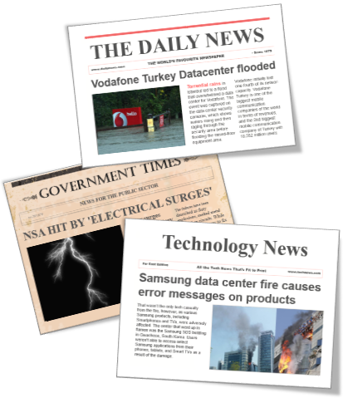
Our hosted solution combines Microsoft Azure Site Recovery (ASR), Microsoft Azure Backup, and Microsoft System Center Data Protection Manager (DPM) to create a best-in-class DR offering—one that allows you to recover from disruptions in minutes, with minimal data loss. We can help you meet these common challenges of disaster recovery:
Ensuring business continuity: If a disruption occurs, our Azure-based DR solution will get you back in business in minutes, with near-zero data loss.
Managing complexity: We handle the complexities of disaster recovery, so you can focus on your business.
Managing large datasets: Our solution is built from the ground up to safeguard high-volume data.
Staying in compliance: Test your disaster recovery procedures as often as you want, without affecting production workloads; be confident you’re meeting compliance objectives.
Choosing a reliable solution: Our solution is based on rigorously tested Azure Site Recovery. ASR is used by organizations worldwide to protect their business-critical data and apps.
Keep your data and applications safe and secure with our cloud-based DR solution.
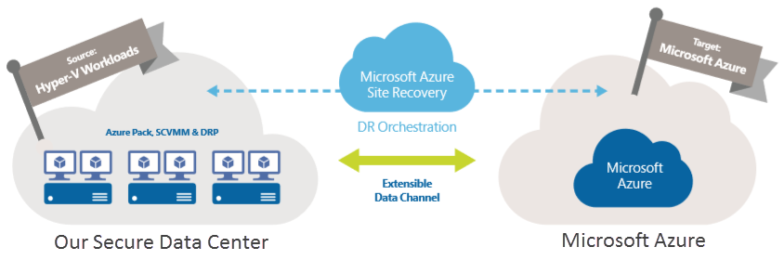
Want to learn more?
Drop us a line at <insert your email address>. Or call us at <your phone number>. We’ll show you how our secure, reliable, and cost-efficient DR solution can safeguard your organization’s sensitive data.

